AI-Assisted Medical Diagnosis using AMIE (Articulate Medical Intelligence Explorer)
PROJECT REPORT
Submitted in the partial fulfillment for the award of the degree of
MLA0104- Artificial Intelligence and Expert Systems

to the award of the degree of
BACHELOR OF TECHNOLOGY
IN
ARTIFICIAL INTELLIGENCE AND MACHINE LEARNING
Submitted by
Vishnu Priya G (192425309)

Under the Supervision of
Dr. Prakash


SIMATS ENGINEERING
Saveetha Institute of Medical and Technical Sciences
Chennai-602105
July-2026
AI-Assisted Medical Diagnosis using AMIE (Articulate Medical Intelligence Explorer)
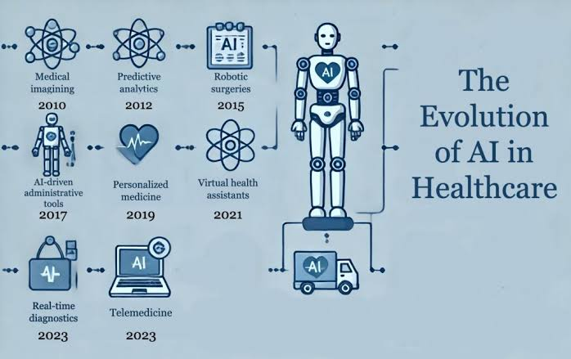

2.Domain: Healthcare
AMIE is one of the latest AI systems developed for medical diagnosis using Large Language Models (LLMs). It is designed to assist doctors by collecting patient symptoms, asking relevant questions, and suggesting possible diseases. Research published in Nature (2025) showed that AMIE performed very well in diagnostic conversations and differential diagnosis, although it is intended to assist—not replace—physicians.

3. Introduction and Background
Artificial Intelligence (AI) is becoming an important part of modern healthcare. AI-assisted medical diagnosis helps doctors identify diseases quickly and accurately by analyzing patient information such as symptoms, medical history, laboratory reports, and medical images.
One of the latest AI systems is AMIE (Articulate Medical Intelligence Explorer). It is based on advanced Large Language Models (LLMs) and is designed to communicate with patients, ask follow-up questions, understand symptoms, and generate possible diagnoses. It acts as a clinical decision-support system to improve healthcare quality and reduce diagnostic errors.

4. Problem Identification
Traditional diagnosis faces several challenges:
- Shortage of experienced doctors
- Increasing number of patients
- Human errors in diagnosis
- Delays in treatment
- Limited healthcare access in rural areas
- High workload on healthcare professionals
These issues can delay diagnosis and negatively affect patient outcomes.
┌──────────┐
│ AI │
└──────────┘
│
┌──────┬──────┬──────┐
▼ ▼ ▼
┌──────┐ ┌──────┐ ┌──────┐
│ ML │ │ NLP │ │ DL │
└──────┘ └──────┘ └──────┘

5. Need for AI Solution
AI helps solve these problems by:
- Providing faster diagnosis
- Improving diagnostic accuracy
- Supporting doctors in decision-making
- Reducing medical errors
- Working continuously without fatigue
- Improving healthcare accessibility
- Assisting hospitals with large patient volumes

AI acts as an intelligent assistant rather than replacing doctors.

Feature | Traditional Diagnosis | AI-Assisted Diagnosis (AMIE)
Diagnosis Speed | Slow | Fast
Accuracy | Depends on doctor's experience | High accuracy with AI analysis
Data Processing | Limited | Analyzes large volumes of medical data
Human Error | More likely | Reduced through AI support
Availability | Limited to hospital hours | Can assist 24/7
Decision Support | Based only on clinical expertise | Supports doctors with AI recommendations
Cost Efficiency | Higher due to repeated consultations | Can reduce unnecessary tests and costs
Patient Monitoring | Mostly manual | Continuous monitoring with AI tools

6. AI Technologies Used
AMIE uses several AI technologies:
- Large Language Models (LLMs)
- Natural Language Processing (NLP)
- Machine Learning
- Deep Learning
- Clinical Decision Support Systems
- Knowledge Representation
- Medical Data Analytics
These technologies enable AMIE to understand patient conversations and generate clinically relevant diagnostic suggestions.
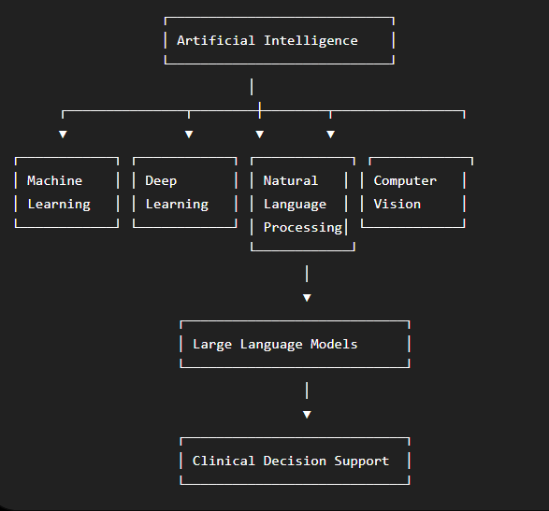

7. Working Mechanism
The AI system works in the following steps:
- Patient enters symptoms.
- AI asks additional questions.
- AI analyzes:
  - Symptoms
  - Medical history
  - Laboratory reports
  - Previous diseases
- The system compares the information with medical knowledge learned during training.
- AI predicts possible diseases.
- The doctor reviews the suggestions.
- The doctor confirms the final diagnosis and treatment.
This process improves diagnostic efficiency while keeping clinicians responsible for final decisions.

8. Data Sources and Processing
The system uses:
- Electronic Health Records (EHR)
- Patient symptoms
- Medical history
- Laboratory test results
- Radiology images
- Clinical guidelines
- Medical research datasets
Data Processing Steps
- Data collection
- Data cleaning
- Feature extraction
- AI model prediction
- Diagnosis ranking
- Clinical recommendation generation

9. Real-World Implementation
AI-assisted diagnosis is already being implemented in:
- Hospitals
- Primary healthcare centers
- Telemedicine platforms
- Diagnostic laboratories
- Emergency departments
Healthcare organizations are increasingly adopting AI for imaging, diagnosis, and clinical decision support, and systems like AMIE demonstrate the potential of conversational diagnostic AI.
Examples include:
- Google Research (AMIE)
- NHS AI diagnostic trials
- Philips AI Healthcare Solutions
- AI-powered telemedicine platforms

10. Impact and Benefits
Benefits include:
- Faster diagnosis
- Higher diagnostic accuracy
- Early disease detection
- Reduced workload for doctors
- Better patient experience
- Lower healthcare costs
- Improved clinical decision support
- Better access to healthcare in remote areas
- Reduced waiting time
- Increased hospital efficiency

11. Challenges and Limitations
Some limitations include:
- Privacy concerns
- Data security risks
- Bias in training data
- Need for high-quality medical datasets
- High implementation cost
- Regulatory approval requirements
- Lack of transparency in some AI models
- Dependence on internet and computing resources
- AI cannot replace clinical judgment
Doctors must always verify AI recommendations.

12. Future Scope and Emerging Trends
Future developments include:
- Personalized medicine
- AI-powered robotic surgery
- Wearable health monitoring
- Predictive disease detection
- Drug discovery using AI
- Explainable AI (XAI)
- AI-powered virtual healthcare assistants
- Precision medicine
- Integration with smart hospitals
- Real-time remote patient monitoring
Healthcare AI is expected to become even more accurate and widely available over the coming years.

13. Conclusion
AI-Assisted Medical Diagnosis using AMIE represents a major advancement in healthcare. By combining Large Language Models, Natural Language Processing, Machine Learning, and Deep Learning, it supports doctors in making faster and more accurate diagnoses. Although AI cannot replace medical professionals, it serves as a powerful decision-support tool that improves patient care, reduces diagnostic errors, and increases healthcare efficiency. As AI technology continues to evolve, it will play an increasingly important role in delivering accessible, reliable, and high-quality healthcare worldwide.

References
[1] G. Singhal et al., “Towards Conversational Diagnostic AI: Articulate Medical Intelligence Explorer (AMIE),” Nature, vol. 640, pp. 460–469, 2025.

[2] World Health Organization (WHO), Ethics and Governance of Artificial Intelligence for Health, Geneva, Switzerland: WHO, 2021.

[3] Google Research, “Articulate Medical Intelligence Explorer (AMIE),” Available: https://research.google/blog/amie-a-research-ai-system-for-diagnostic-medical-reasoning-and-conversations/

[4] National Institutes of Health (NIH), “Artificial Intelligence in Healthcare: Applications and Challenges,” Available: https://www.nih.gov/

[5] Mayo Clinic, “Artificial Intelligence in Healthcare,” Available: https://www.mayoclinic.org/
[6] IBM, “Artificial Intelligence for Healthcare,” Available: https://www.ibm.com/healthcare

